Lab – 8

ESP32 Basics – Blinking Onboard LED
1. Aim
To study ESP32 basics and blink the onboard LED using a simple program.

2. Theory
ESP32 is a powerful microcontroller with built-in Wi-Fi and Bluetooth capabilities.
Comparison with Arduino:
- Faster processor
- Wireless communication support
- More GPIO pins
- Dual-core processing
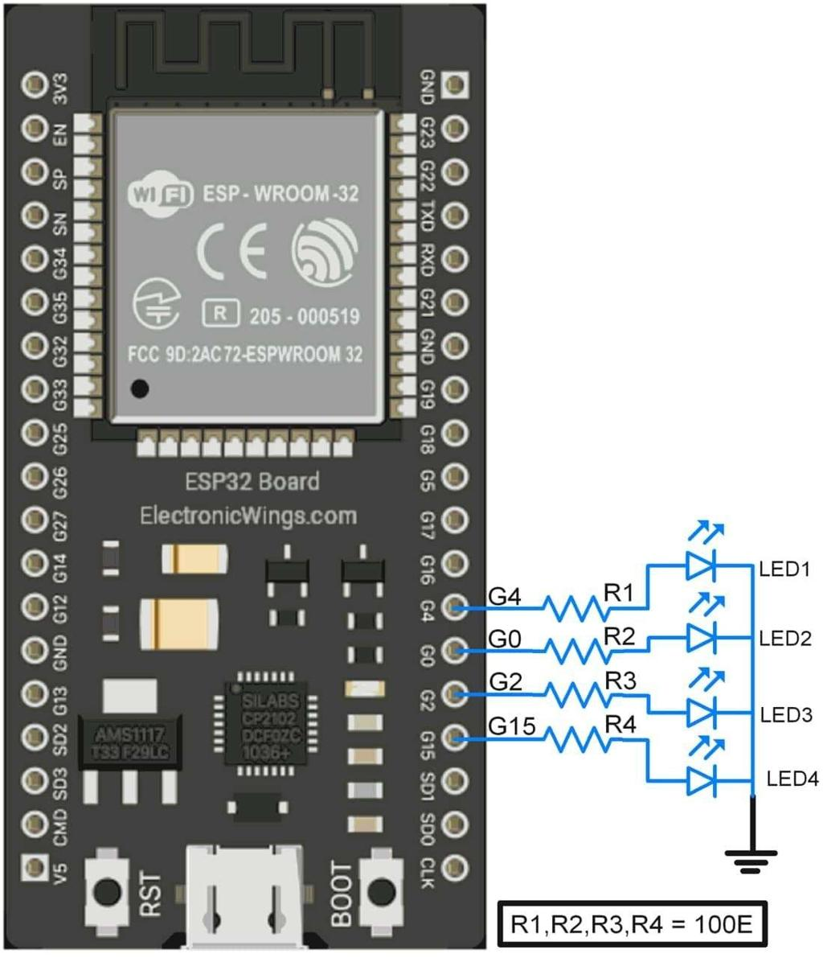
3. Apparatus / Requirements
- ESP32 board
- USB cable
- Arduino IDE

4. Circuit Diagram

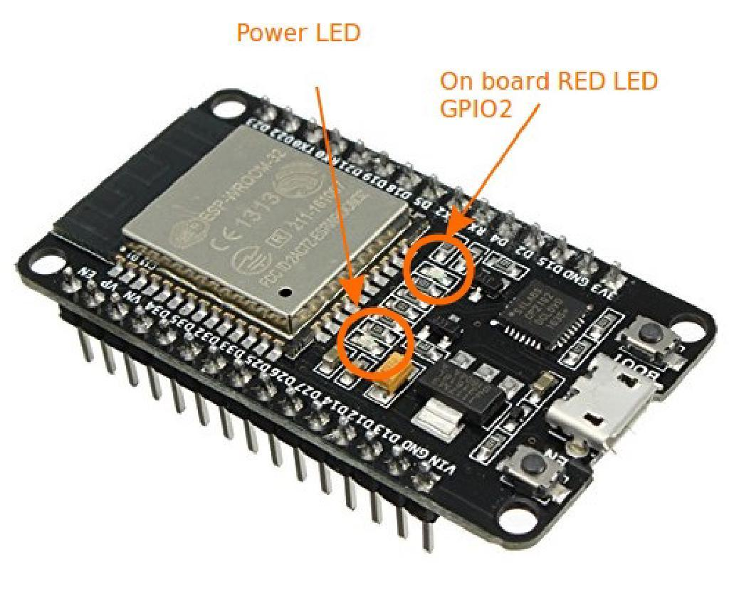

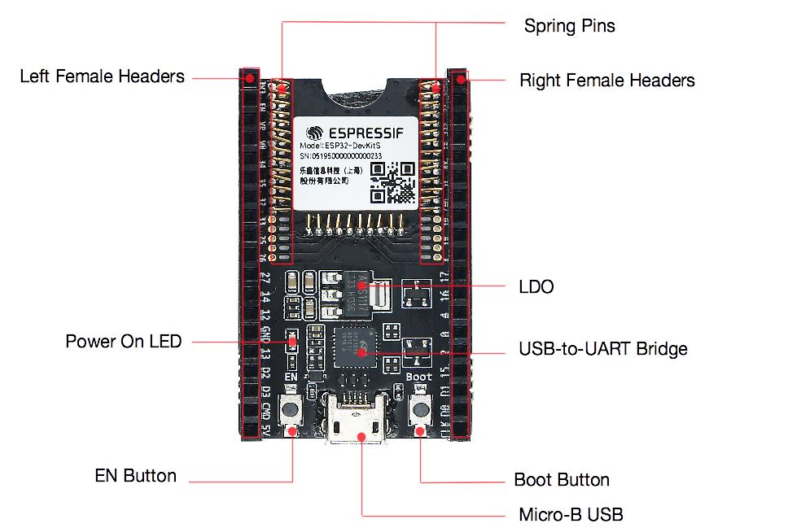

5. Procedure
- Connect ESP32 to computer
- Install ESP32 board package in Arduino IDE
- Write LED blink program
- Select ESP32 board and COM port
- Upload code
- Observe LED blinking

6. Program / Code
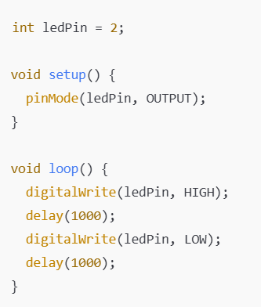
7. Observations
- LED blinked continuously
- ESP32 uploaded code successfully
- Faster execution compared to Arduino observed

8. Result
The onboard LED of ESP32 was successfully controlled using Arduino IDE programming.

